Kevin Scardino: Project Manager, GIS Analyst
Nathan Andrews: Assistant Project Manager, Web Master
Barkley Jenkins: GIS Technician, Data Specialist
Mukarram Kamran: GIS Analyst, Technical Writer

Completed on: 10 December 2012

The City of New Braunfels
Parks and Recreation
Asset Management Project

Prepared by: The G.A.M.E.S.

Abstract:
Our group the GAMES, was assigned a request for proposal from the City of New Braunfels for a project working along-side the GIS, Parks and Recreation, and Maintenance departments. The project proposed by the city was summarized as an asset management system using ArcGIS Desktop 10.0/10.1 and Accela, an asset management software specialized for government use. The goal was to develop a geodatabase of the parks across New Braunfels and populate it with what they desired to track as an asset inside those parks. This helps the city employees better maintain the various parks across New Braunfels and save money for the local government. With the success of the project, the rest of the departments in the city of New Braunfels can begin to use Accela to track their various assets. The successful integration of Accela into a city government greatly benefits the government by saving money, time, and labor.

Table of Contents

1. Introduction

1.1. Problem Statement...………………………………………………………… 1

1.2. Purpose…....……………………………………………………………..….. 2-3

1.3 Scope………………………………………………………………………….. 3

2. Literature Review……………………………………………………………………… 3-4

3. Data…………………………………………………………..…………….……………. 5

3.1 Field Work…………………………………………………………………….. 6

3.2 GPS & GIS……………………………………………………………………. 6-7

4. Methodology………………………………………………………………….…..……… 7
4.1. Park Boundaries & Landscape Maintenance ….……………………….. 7-9

4.2. Five Assets .……………………………………………………………...... 9-11

4.3 Accela .……………………………………………………………………… 11-13

5. Results…………………………………………………….….….…………………… 14-18

6. Discussion……………………………………………………….…..……………….. 19-20

7. Conclusion ………………………………………….……………….……………….. 20-22

8. References…………………………………………….……………….……………… 23

9. Metadata……………………………………………………………………………….. 24

10. Appendix I. Flow Charts…………………………………………………………… 26-30

11. Appendix II. Maps……………..…………………………………………………… 31-33
12. Appendix III. Attribute Tables…………………………………………………….. 33-42
13. Appendix IV. Personal Reports……………..……… (Not numbered, located at end)

- INTRODUCTION
  - PROBLEM STATEMENT
The management of any Government Agencies Department’s assets is crucial in order for things to be organized and run smoothly. For instance, just think if your cities Municipal Government’s Waste Management Department was unable to manage their assets correctly. Can you just imagine how many upset people there would be complaining about over flowing trash bins and the smell? The Parks and Recreation Department’s management of assets can also become a real hassle for cities with increasing populations or that have unique features to attract visitors. To counter these management problems companies like Accela have developed software to assist City and Government Agencies. Currently a number of cities across Texas are using Accela management software to help manage their Municipal Governments in some form. For example “…the city of Fort Worth, Texas, has selected Accela Automation® to track and manage key assets. The city’s Storm Water Management Division, and the Transportation and Public Works Department will deploy Accela Automation, combined with mobile and GIS capabilities, to easily view and share information including work orders, inspections, costs and more, anywhere in Fort Worth’s more than 300-mile radius” (Chen). Another city in Texas, New Braunfels, has joined its City Government with Accela and is in the process of implementing it into their various departments. The City’s GIS Analyst and Accela Manager William Flynn has been playing a major role in getting this process going.
  - PURPOSE
In order to speed up the process a little Mr. Flynn had contacted our group, The GAMES, with a RFP for the purpose of creating an asset based GIS schema for their Parks and Recreation Department. That schema would then be implemented into the City’s Accela asset management system, Accela Automation. Upon the completion of this proposal the City of New Braunfels Parks and Recreation Department will be able to better manage and inventory their assets with Accela Automation by implementing such things as preventative maintenance schedules. The Department should also be able to create work orders whenever needed and it might become possible to even begin allowing citizen access to Accela in order to speed up permit issuing and processing for Park assets like picnic areas and pavilions. Other Departments too could utilize this data in the future and build off of it. Understanding all these possibilities, The GAMES worked long and hard hours over the past few months and completed the following objectives in order to supply the City of New Braunfels with what they requested in their proposal:
• Conducted various needs assessments with Mr. Flynn and the City’s Parks and Recreation Department Personnel Kelly Eby and Kelsey Heiden.
• Designed 2 GIS Schema’s or geodatabases using ArcMap 10.1/10.0 and ArcCatalog around the assets that the Parks and Recreation Department’s maintain.
• Conducted field work with Trimble GeoXT GPS units as well as moderate digitizing in order to collect any necessary data.
• With the help of Mr. Flynn, the City of New Braunfels GIS Analyst/Accela Manager, The GAMES synched the GIS schemas/geodatabases with Accela. This linked in all of the Parks and Recreation Department’s assets collected into the Accela Management system, Accela Automation.
  - SCOPE
The scope of this project centered on 35 parks and 83 properties for landscape maintenance in the City of New Braunfels as can be seen in Appendix II Figure 2.1. In addition there were another 5 assets for the park system. These five assets included picnic areas, pavilions, trash cans, spigots and drinking fountains. The collection of sample data for these five assets GIS schema/geodatabase was centered on Landa Park but the GIS schema they used can be implemented for any other park as needed in the future. See Appendix II Figure 2.2 for a detailed map of Landa Park and these five assets.
- LITERATURE REVIEW
Presenting Accela Automation to a city government can make any GIS analyst very stressed. However, once that city government realizes how beneficial the Accela software can be, they will praise that stressed GIS analyst and if this was a perfect world; he would receive a hefty pay increase for saving his city’s government so much money. Unfortunately this is not a perfect world, and city governments are always on tight budgets, looking for any way to save a penny while bettering their citizens.
Accela Automation offers asset management software that manages “building, planning, and licensing activity” (From). The software syncs with a GIS geodatabase and allows city employees to use a user friendly based GIS system through Accela. The city government of Oklahoma City, Oklahoma needed to improve their city government starting with the IT department. Accela’s “web based, enterprise technology” was exactly what they needed to accomplish their goals (From). These goals included “integrating multiple departments” of the city so that all departments can access the same information. Another goal was to “improve service to citizens” so that “local businesses and the development community” could have easier access to “permitting and licensing processing” (From). Lastly, the Oklahoma City government wanted to cut down on the paper system and labor hours of inspections by “reducing inspection turnaround time” (From).
Now working and providing positive results, Accela Automation is proven to be successful in managing the assets of the Oklahoma City government. The service to the citizens was greatly improved, unlimited integration became available, inspections became more time successful, and the city government saw great savings. Incorporating Accela Automation can help any city government save money and become “tech savvy” (From).
- DATA
Preliminary data collection was quite easy to obtain compared to the rest of the groups in the class. That is because our client, William Flynn, provided us access to the New Braunfels FTP website. William provided a special folder with all the reference data that we would possibly need for this project. Some of that data included park boundaries, irrigation database, planning database, various tree data, and various park assets that were collected in the past. The first objective of this project was to design a geodatabase of park boundaries and landscape maintenance layers for the selected parks and properties.
The City of New Braunfels website has a GIS section where there is an interactive data extract that is available to the public. We decided to take advantage of this data extract and obtained the parcels for all of the parks and property boundaries. Kelsey Heiden, administrative secretary for the Parks and Recreation Department, and Kelly Eby, Urban Forester, provided The GAMES with two excel tables that defined their desires of parks for park boundaries and landscape maintenance properties. We used the parcels to base our park boundaries and landscape maintenance property boundaries. However, we needed to make edits to a few of the parcels to fix certain boundary issues. After making these edits we had our base data for our first two layers in our first geodatabase. The next objective of this project was to conduct field work and collect the desired assets throughout Landa Park.

  - FIELD WORK
Landa Park is the pride and joy of all the parks in the Parks and Recreation Department. It is also the park that our client directed us to collect specific assets for our second geodatabase. These five assets included pavilions, picnic areas, trash cans, spigots, and drinking fountains. The picnic areas and pavilions were collected through our Trimble Geo XT 6000. The spigots, trash cans, and water fountains were digitized through 1:400 and 1:1,000 aerial maps. We used the paper maps and walked throughout the park confirming the locations of these assets.
  - GPS & GIS
As mentioned in the 3.1, the GAMES used a Trimble Geo XT 6000 to conduct our data collection in the field at Landa Park. In order to prepare for this field work, we needed to do a lot of planning and created a data dictionary to record the various assets. The first step of preparation was to check the mission planning, assuring that the PDOP would not be too high. This is done in order to assure that the data collected would be accurate. The next step involved importing a data dictionary to the unit. We utilized Pathfinder Office in order to create it and export it to the GPS unit. After data collection in the field, we used Pathfinder Office again to upload the data from the GPS unit. Then we differentially corrected the data using Pathfinder Office again. Correcting the data is done to make the feature position more accurate. After differential correction, the data is then exported as shapefiles to ArcGIS. Here is where we did some more editing of the data. This editing included accounting for the offsets, which were used due to tree canopies, and making sure the proper fields were populated with the proper information for each picnic area or pavilion. Lastly, we created a geodatabase of these five assets for Landa Park in ArcCatalog. This was done in order to send the assets to Accela. Now our methodology section will explain all the manipulation we did with this data to make it sync with Accela properly.
- METHODOLOGY
There were three major sections for our methodology. The first section consists of the GIS portion of creating the Park Boundaries and the Landscape Maintenance data layers. While the second section consists of the GIS data from five assets that can be found within the areas maintained by the Parks and Recreation Department and consisted of: picnic areas, pavilions, spigots, drinking fountains, and trash cans. Then there is a section that details the synching of all the aforementioned GIS data with the Accela Management system, Accela Automation.
4.1 PARK BOUNDARIES & LANDSCAPE MAINTANENCE
To begin with the first section, the group needed to find a way to collect GIS data from a list of parks and landscape maintenance properties that was supplied in spreadsheet format by Kelsey Heiden of the Parks and Recreation Department. In order to do this the group downloaded the City of New Braunfels parcel data from the City’s GIS Extraction website and overlaid the City’s Address data, from the same website, on top of it. This allowed us to reference the paper based addresses with those in ArcMap and determine where the properties parcel data was. Giving us a starting point to begin organizing data and seeing what we would need to collect later by digitizing. We then exported the necessary parcel data into their new layers called Park Boundaries and Landscape Maintenance.
Some parks were difficult to find even with the addresses and so we referenced an old/incomplete park boundary shape file that the City of New Braunfels had on their FTP site to help us locate them. Other parks and landscape maintenance properties did not take up the entire parcel dimensions or did not have parcel data and so we had to go in and manually edit these boundaries by digitizing over aerial photos, taken Dec 2011, with references to the FTP site’s park boundary shape files, or by best approximation based on acreage data from the spreadsheet. Once we had all of the data merged into their respective layer’s we then created the attribute tables based upon the Parks and Recreation Departments spreadsheets received during a needs assessment. It was a little challenging to get the proper and necessary data from the paper spreadsheet due to its format, not being compatible to ArcGIS. Some of the Attribute table’s fields were benefited by having domains created for them in order to lessen confusion and to make sure the correct data is input. The attribute table for the Park Boundaries layer had only one domain created in it for the Park Type. While the Landscape Maintenance layer had two domains: Property Type and Property Classification. When the domains were finished the group then populated the attribute fields with the data provided on the spreadsheet from Kelsey Heiden. A unique Asset ID was assigned to each property at this time for Accela or other software to be able to find the correct data later on. This completed the GIS portion of the first section: Park Boundaries and Landscape Maintenance layer data and we saved them as Parkassetsworkingmap.mxd for the last step, synching with Accela, which will be covered later in 4.3.

4.2 FIVE ASSETS
This second section covers the asset GIS schema data collection and processing for the five park assets: picnic areas, pavilions, spigots, drinking fountains and trash cans. For this step in our project we needed to collect spatial data on the five aforementioned assets. Needless to say collecting data from all of the parks was out of the question so Mr. Flynn narrowed our scope down to Landa Park in order to take a sampling of data to test the overall schema. To accomplish this we decided to digitize in the spigots, drinking fountains and trash cans and to use the Trimble GeoXT to take more precise spatial measurements of the picnic areas and pavilions. However, the aerial photographs we had offered little chances of locating such small assets and so we needed a solution. More of a problem was all the tree canopies covering the majority of the park and obscuring details in the aerial photographs and causing issues with our GPS device. The GPS devices issues were resolved by applying an offset to our GPS shots. These offsets were entered into the Trimble GeoXT manually and included the directions of offset, recorded using a compass, and the distances. The distances were measured out with a tape measure to the nearest inch. This allowed us to edit the offsets later in the GIS and still get accurate readings. In order to locate and collect inventory data for these five assets, the group went out one day with a binder of hardcopy printout aerial photographs at 1:400 and 1:1000 scale of sections of the entire park and manually sighted, plotted and inventoried picnic areas, pavilions, spigots and drinking fountains. The inventory data consisted of picnic table counts, BBQ pit presence and size, and presence and count of trash cans. Then another day the group went out using the same method and actually collected the locations of a sample of 85 trash cans in the park. We limited it to 85 because of the incredible amount of trash cans in the park.
The group’s next task was to take the paper data and use that to digitize the information into ArcMap. Each asset got its own respective layer and we carefully digitized in the spigots, drinking fountains and trash cans using the create feature tool. Once we had all the assets digitized into ArcMap based off the paper data we started to look at the Trimble GeoXT data. The GPS data for picnic areas and pavilions was uploaded from the Trimble GeoXT device onto a computer using Pathfinder Office software. The data was then cleaned and edited, removing all unnecessary data like points not in feature or duplicate data. The data was then differentially corrected to increase the precision of the GPS recordings. This cleaned and differentially corrected data was then exported into ArcGIS/ArcMap and separated into their respective layers: picnic areas and pavilions. With these five assets in ArcMap the group was now ready to create the attribute tables for each asset layer. The attribute table’s fields were created using references from the irrigation.gdb and parks.mdb data, retrieved using the FTP site, as well as from needs assessments with Mr. Flynn and the Parks and Recreation Department’s employees. Once the five assets attribute tables were completed the group began to create domains for specified fields. These domains were: Trash can type, Trash can lid type, Trash can mount, and BBQ pit size. With the domains created all that was left to do was populating the five assets’s attribute tables based on the data The GAMES collected in the field at Landa Park. With that all finished we were able to save the asset layers as landaparkassets.mxd. Thus ending the GIS portion of this section and bringing it up to speed with the first section and ready to be synched with Accela.
4.3 ACCELA
Now that the Park Boundaries, Landscape Maintenance, picnic areas, pavilions, spigots, drinking fountains and trash can layers have been finished in GIS and saved to their respective .mxd file our group was ready to work on the final section with Mr. Flynn, synching the data with Accela. This process is slightly more complex and consisted of multiple processes between the ArcGIS components and Accela. To begin the process, the initial geodatabase we created “parkassets.gdb” containing the data used for the ArcGIS components needed to be copied over to one of the City of New Braunfels dedicated Enterprise servers. The group watched and learned from Mr. Flynn as he demonstrated this using the tool “Create Enterprise Geodatabase”. After the parksassets.gdb was copied over it had to be registered as versioned to verify that it is “ok” to use before it can be. The next step was to link the parkassets.gdb data on the Enterprise server to a map service, ArcGIS Server Manager, so that Accela’s map service, AccelaSDE, could recognize it. This entailed uploading a copy of the Parkassetsworkingmap.mxd to ArcGIS Server Manager. This allowed the ArcGIS Server Manager to associate with and find the data on the City of New Braunfels Enterprise server. Then Mr. Flynn explained to our group that the Accela’s map service, AccelaSDE, needs to be able to associate with ArcGIS Server Manager in some way. To do this the group once again associated the Parkassetsworkingmap.mxd but this time using the AccelaSDE.mxd file. The purpose of this is to get the Park Boundaries and Landscape Maintenance layer data on the .mxd file that Accela recognizes while maintaining and keeping the ArcGIS data on the Enterprise Server. . Once the Parkassetsworkingmap.mxd file had been associated with AccelaSDE.mxd the software had to be restarted, as a way of refreshing the content, to see any changes. With this done it is now possible for Accela Automation to access the “parkassets.gdb” data on the Enterprise Server through AccelaSDE and the ArcGIS Server Manager.
However, access doesn’t mean that it is usable yet. In order for the Parks and Recreation Department to be able and utilize this data in Accela a few last steps were involved in Accela Automation. First after logging into the Accela Automation software we had to modify certain configurations under the AA Admin Tools/GIS Service options. Mr. Flynn and the group adjusted the configurations in order to point the layers to the Asset ID’s attribute field. This was done in order for Accela Automation to be able to retrieve the correct layer information from the data on the Enterprise Server. With Accela Automation now being able to retrieve the correct data the Park Boundaries and Landscape Maintenance data was ready to be tested. But before that The GAMES followed similar steps to add our other geodatabase, the parkassets2.gdb, data to the City of New Braunfels Enterprise Server. Except for this we wanted to combine only parkassets2.gdb’s data to the parkassets.gdb on the Enterprise Server and not the entire geodatabase. So we used the tool “Feature Class to Server” and added only the data we wanted to the parksassets.gdb. Next it was loading the “parkassets2.gdb’s” landaparkassets.mxd file consisting of the picnic areas, pavilions, drinking fountains, spigots, and trash cans to the map services ArcGIS Server Manager and in AccelaSDE. Then the group followed the same steps as mentioned with the Park Boundaries and Landscape Maintenance layers earlier to get these five assets ready to be utilized in Accela Automation. The absolute last thing The GAMES did was to run tests in Accela Support, a support environment for testing, on the finalized copies by assigning preventative maintenance to an asset or assigning fake work orders which will be discussed in detail in section 5 with the results. For a more in depth look at our methodology please refer to Appendix I which show Flow Charts depicting the methodology we used in its entirety.

- RESULTS
The first two screen shots are what the Parks and Recreation Department had populated in their Accela Assets. Creating an asset ID number was our first goal in order to properly sync our geodatabase with Accela.
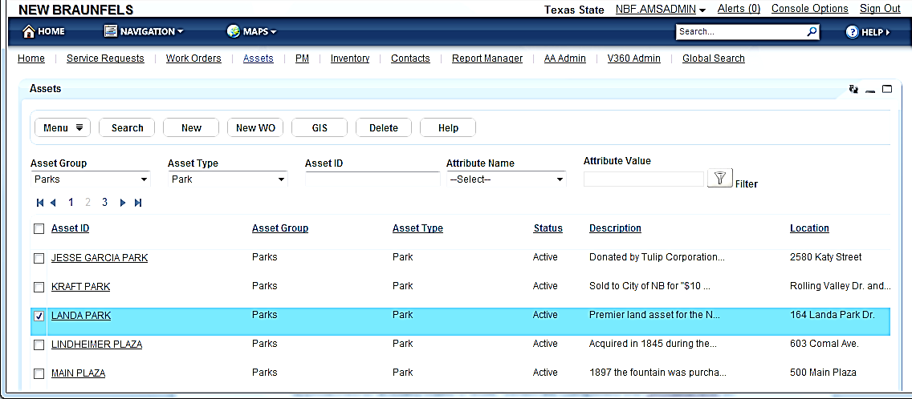

This is a screen shot of the specific assets that Landa Park and every other park across the City of New Braunfels collect and track. Our goal here was to cut this down to exactly what the Parks and Recreation Department requests. 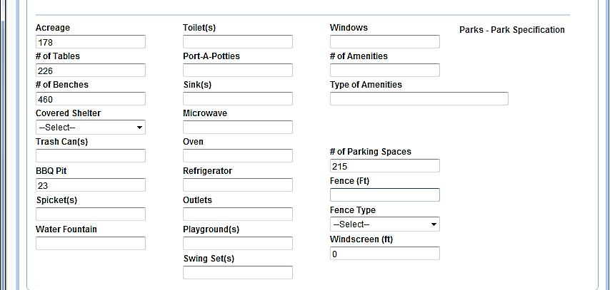
Our newly created asset ID has been created and can be seen in the next screen shot. 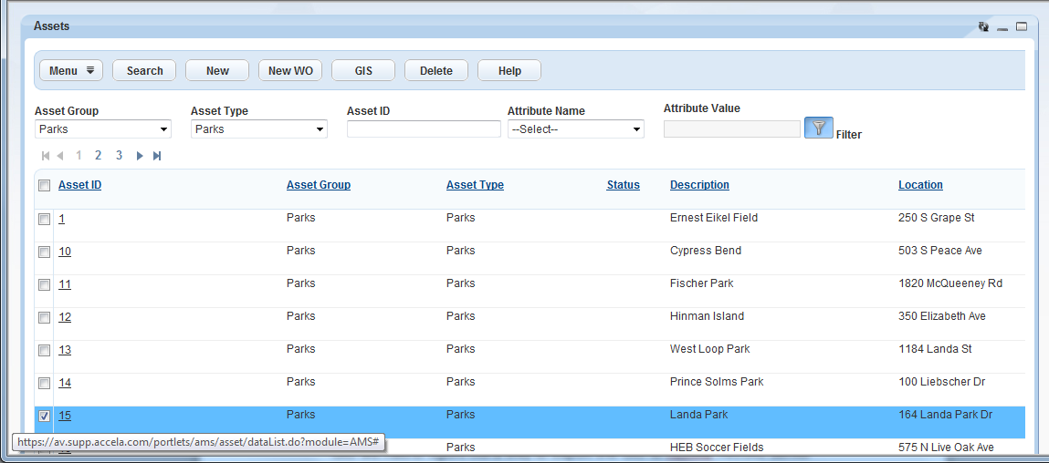

This screen shot shows the 4 assets we collected throughout Landa Park. It also shows the requested attributes collected for each asset. 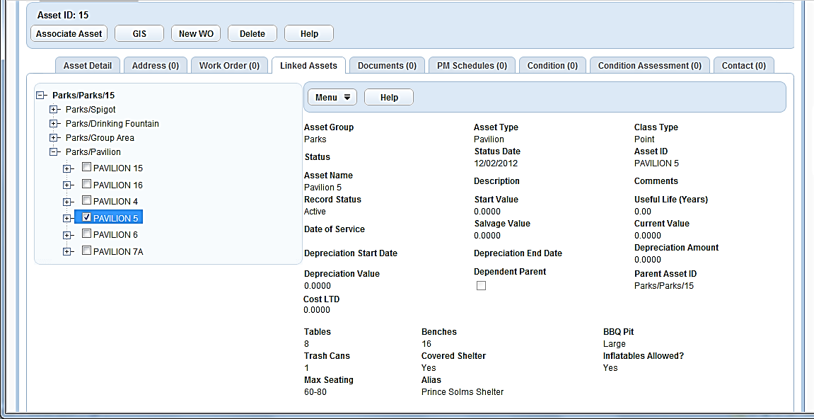
This is an example of how to assign a work order. This one is for trash removal of plastic bins in asset ID # 15 which turns out to be Landa Park. 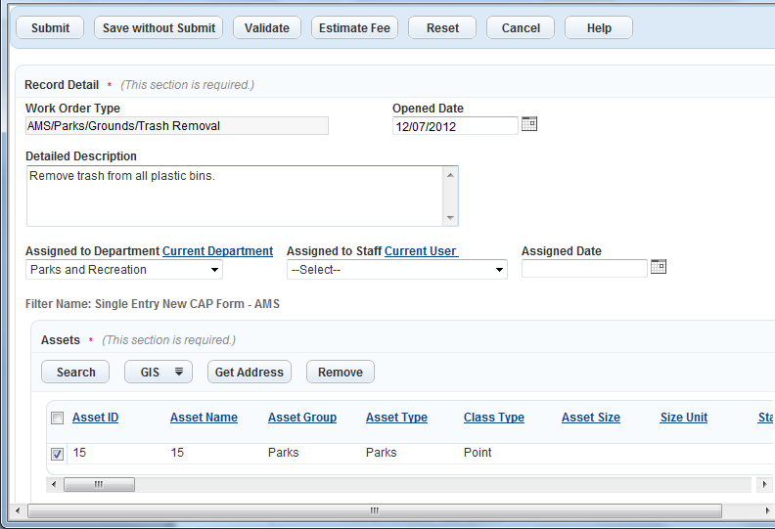

Accela would show the city employees a similar map to the one in Figure 2-3, in order to locate all plastic bins throughout the park and complete the work order.

This screen shot shows how to make a preventive maintenance schedule for mulching twice a year at the City Library. 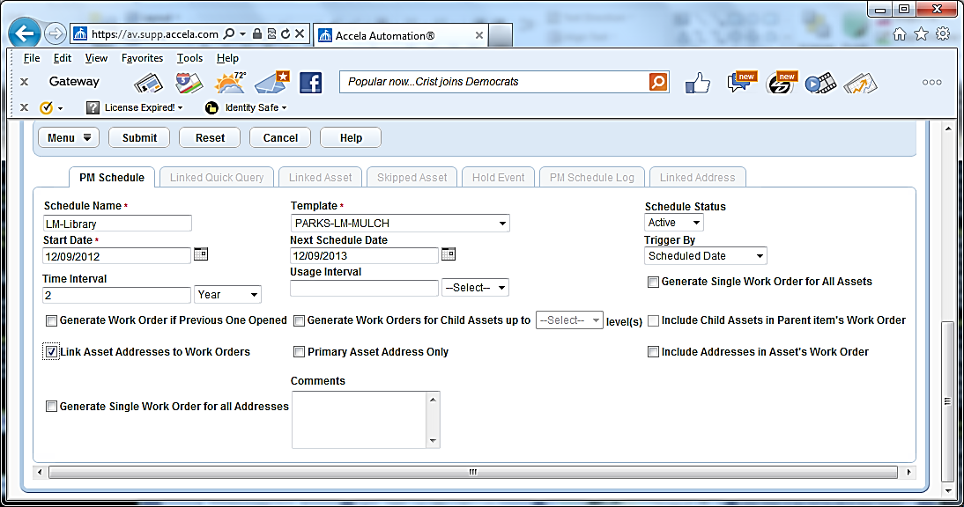
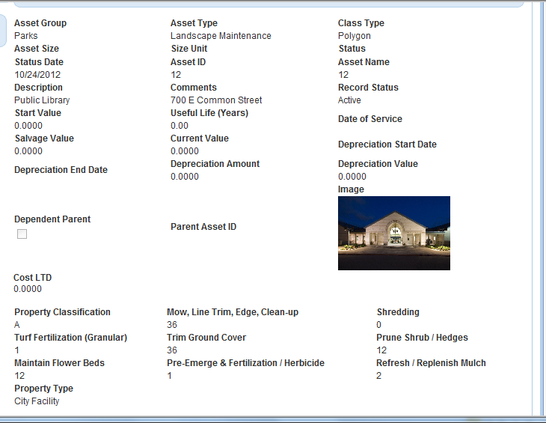
Here below is the landscape maintenance schedule created for the City Library.

- DISCUSSION
After completing our first geodatabase of the park boundaries and landscape maintenance layers, our first goal was to assign a unique asset ID number to each park and property in the geodatabase. This was done in order to assure proper synchronization with Accela. Secondly, we trimmed the attributes collected in Accela to the requests of the Parks and Recreation Department. We conducted our field work based on the desires of the Parks and Recreation Department and only collected picnic areas, pavilions, spigots, trash cans, and water fountains. For the picnic areas and pavilions we recorded the number of benches and tables as well as the size of the BBQ pit. We created a domain for the BBQ pit because there were only three different sizes throughout Landa Park.
Work Orders are another significant component of Accela’s arsenal. As mentioned in the results, there is a work order assigned for Landa Park, to remove trash from specifically the plastic trash cans in the park. Once the city employees receive that work order, they would receive a similar map shown below the work order in order to locate each plastic trash can.
One of the most beneficial components of Accela is the preventive maintenance. Preventive maintenance (PM) is where Accela saves labor and money throughout the city government. An example of a preventive maintenance schedule is shown in the results and it shows how assign a landscape maintenance order to mulch the flower beds at the city library twice a year. Below that shows all the different types of landscape maintenance orders with the PM mulch schedule set. PM automatically generates work orders due to set schedules like the example of the city library.
Synchronizing the GIS with Accela was the major implication that we had to deal with. Although it was the major implication, it only took a few different approaches to actually make it work. When we completed the geodatabase in GIS we had to figure out a way to export the GIS to Accela. ArcGIS server manager served as the GIS map service and AccelaSDE served as the Accela map service. With these two map services, synchronization of the GIS to Accela becomes possible. We successfully imported our geodatabase from ArcGIS into Accela and any edits we made on certain data in the GIS would also be edited in Accela. However, the challenge was to get the flow from GIS to Accela to go backwards. At first we edited a certain feature in Accela GIS, but the same feature in the GIS geodatabase never changed. Once we figured out the problem, our goal of successfully exporting two geodatabases from ArcGIS to Accela has been accomplished.
- CONCLUSION
The G.A.M.E.S final design of the GIS structure used for the integrated asset management system allows the New Braunfels Parks and Recreation Department the tools to be able to effectively and efficiently maintain numerous assets. Endless opportunities can be conceptualized with the ability to effortlessly access asset data that can be managed both categorically and spatially Parks and Recreation Department asset information that contains associated data such as park zones, pavilions, trash cans, barbecue pits, water spigots and drinking fountains can be utilized to provide the community with the best facilities possible.
Accela asset management software coupled with a geographic information system provides the New Braunfels Parks and Recreation Department with a powerful tool that can be used in practically every aspect of their day to day operations. The systems integration allows the ability for users to not only utilize the power of comprehensively managing diverse asset data types, but to visualize the asset on an interactive map designed specifically to enhance the utility of the asset management system. With this partnership asset information can be managed spatially either with the assets location or topographic relationships; as well as by textual criteria associated with the asset. Automatically generated preventative maintenance reports can be created remotely by users which only need an internet connection and secure access authorization. Assets can be inputted, located and managed on site; furthering the detail and utility of the system as well as providing invaluable information exactly when needed.
While further progress will be necessary for the asset management system to be fully utilized, the foundation set by The G.A.M.E.S will play a pivotal role to the daily implementation of the system in the New Braunfels Parks and Recreation Department. With their employment of the asset management system continuing into the future, the amount of resources saved is incalculable with the system expanding to fit the coming demands of the ever growing New Braunfels Parks and Recreation Department. With similar G.I.S. schemas to The G.A.M.E.S’s design and with correct implementation, asset management systems can but utilized throughout all levels of government; saving invaluable funds that can be used to educate, heal, save, and better the lives of its citizens as well as people throughout the world.

- REFERENCES
Chen, Allen. "Fort Worth Selects Accela Automation for Citywide Asset Management." Fort Worth Selects Accela Automation for Citywide Asset Management. Accela, 5 Apr. 2012. Web. 04 Dec. 2012. <http://www.accela.com/company/news/press-releases/372-fort-worth-selects-accela-automation-for-citywide-asset-management>.

"Oklahoma City." Oklahoma City. Accela, n.d. Web. 05 Dec. 2012. <http://www.accela.com/images/resources/success_stories/Oklahoma_City_OK_Licensing_Solution_SS.pdf." n.d. Accela. 12/2/2012.>.

- METADATA
Identification_Information:
Description:
Abstract: This data was originally obtained from the City of New Braunfels FTP site.
Time_Period_of_Content:
Time_Period_Information:
Range_of_Dates/Times:
Beginning_Date: September 25, 2012
Ending_Date: December 10, 2012
Data_Quality_Information:
Attribute_Accuracy:
Attribute_Accuracy_Report: The accuracy of the data from the FTP site was sufficient enough to accomplish our goals.
Completeness_Report: All of the data we needed for the project could not be accessed solely through the FTP site. We had to utilize the GIS extract from the New Braunfels website.
Spatial_Reference_Information:
Horizontal_Coordinate_System_Definition:
Geographic:
Geographic_Coordinate_Units:
Degree",0.0174532925199433
Foot_US",0.3048006096012192
Planar:
Map_Projection:
Lambert_Conformal_Conic:
Standard_Parallel:
PARAMETER["Standard_Parallel_1",28.38333333333333]
PARAMETER["Standard_Parallel_2",30.28333333333333]

Longitude_of_Central_Meridian: PARAMETER["Central_Meridian",-99.0]
Latitude_of_Projection_Origin: PARAMETER["Latitude_Of_Origin",27.83333333333333]
False_Easting: PARAMETER["False_Easting",1968500.0]
False_Northing: PARAMETER["False_Northing",13123333.33333333]
Distribution_Information:
Distributor:
Contact_Information:
Contact_Organization_Primary:
Contact_Person: William Flynn, City of New Braunfels GIS Analyst and Accela Administrator.
Resource_Description: FTP website hosted by the City of New Braunfels.
Available_Time_Period:
Time_Period_Information:
Range_of_Dates/Times:
Beginning_Date: September 25, 2012
Ending_Date: December 10, 2012
Metadata_Reference_Information:
Metadata_Access_Constraints: Only use for G.A.M.E.S. project.

- APPENDIX I. Flow Charts
FIGURE 1.1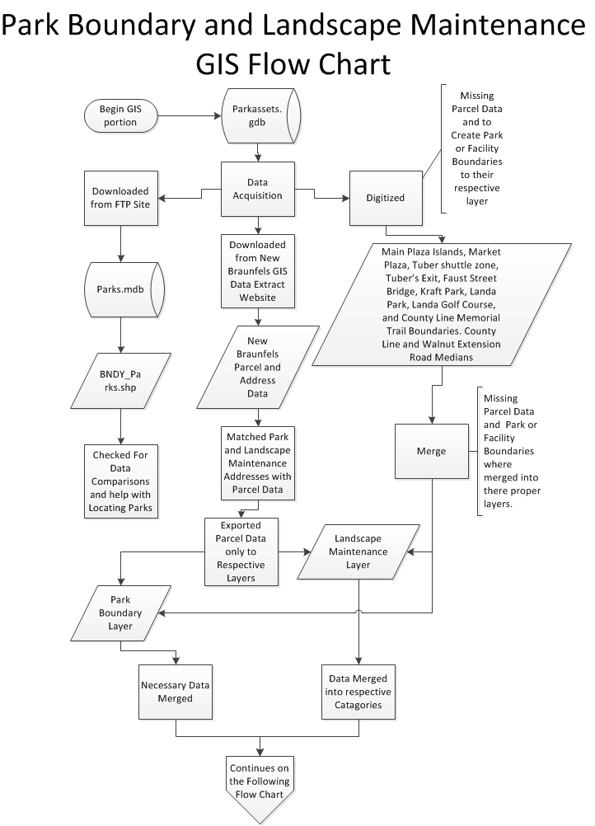
FIGURE 1.2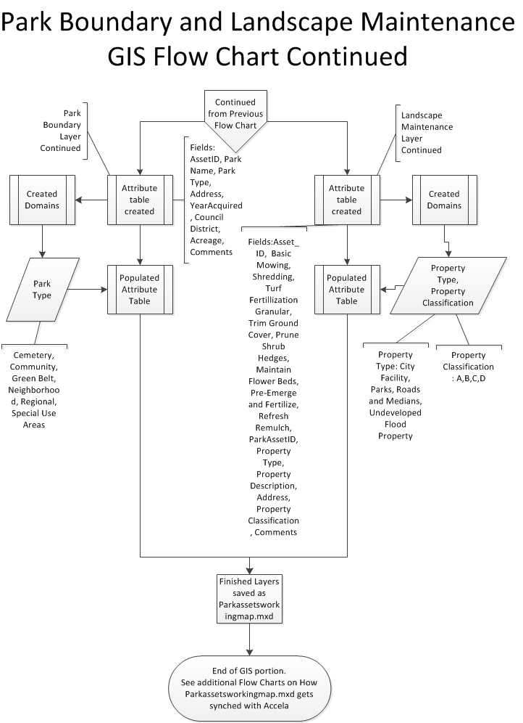

FIGURE 1.3
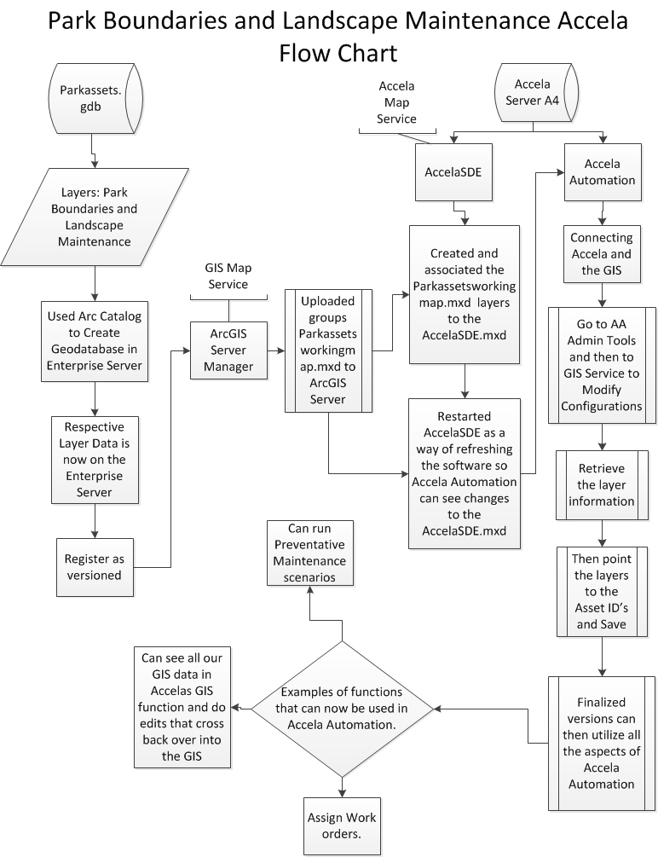

FIGURE 1.4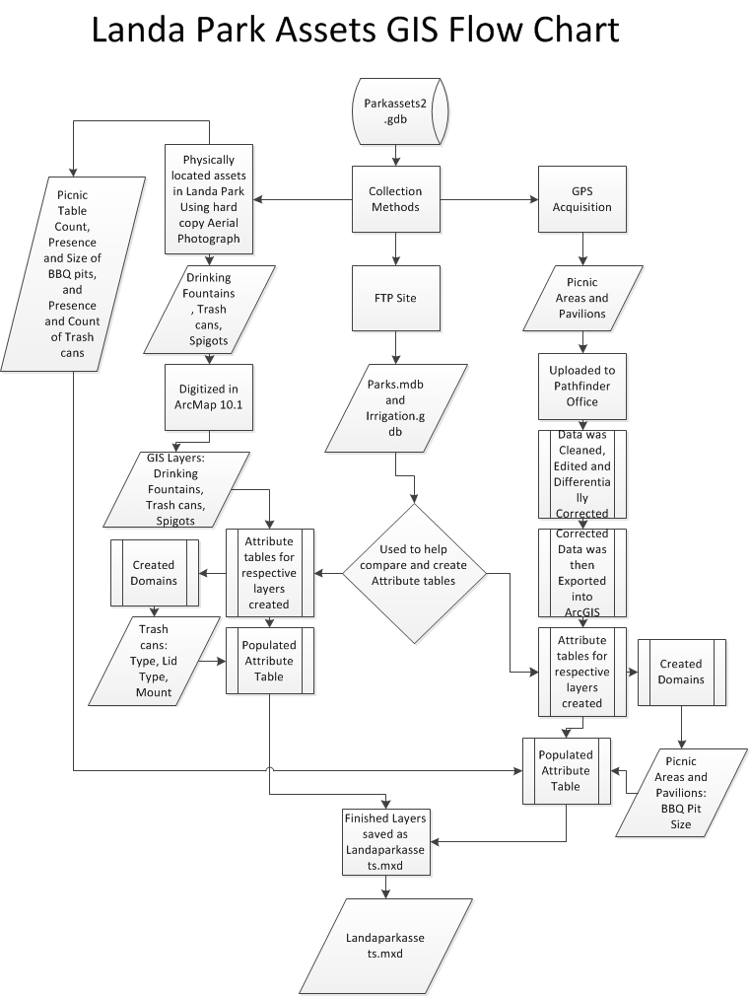

FIGURE 1.5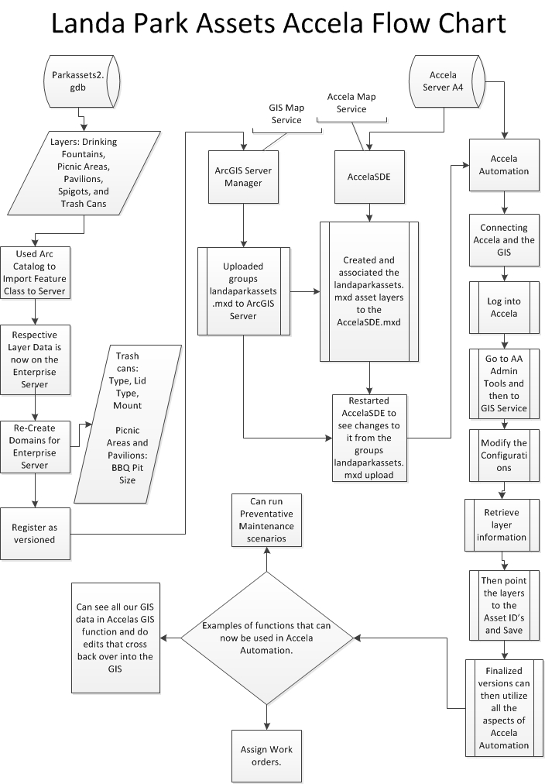
- APPENDIX II. Maps
FIGURE 2.1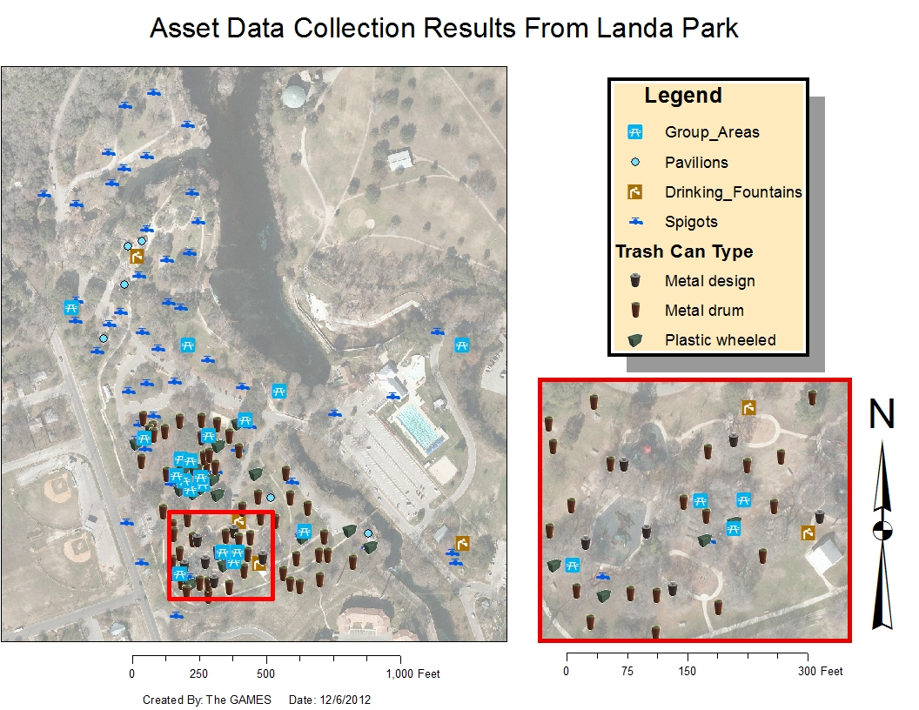

Figure 2.2
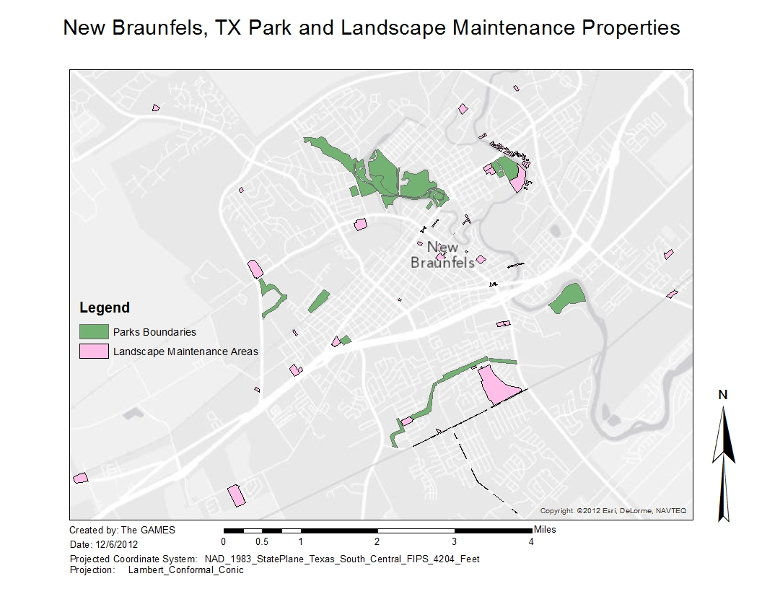

FIGURE 2.3

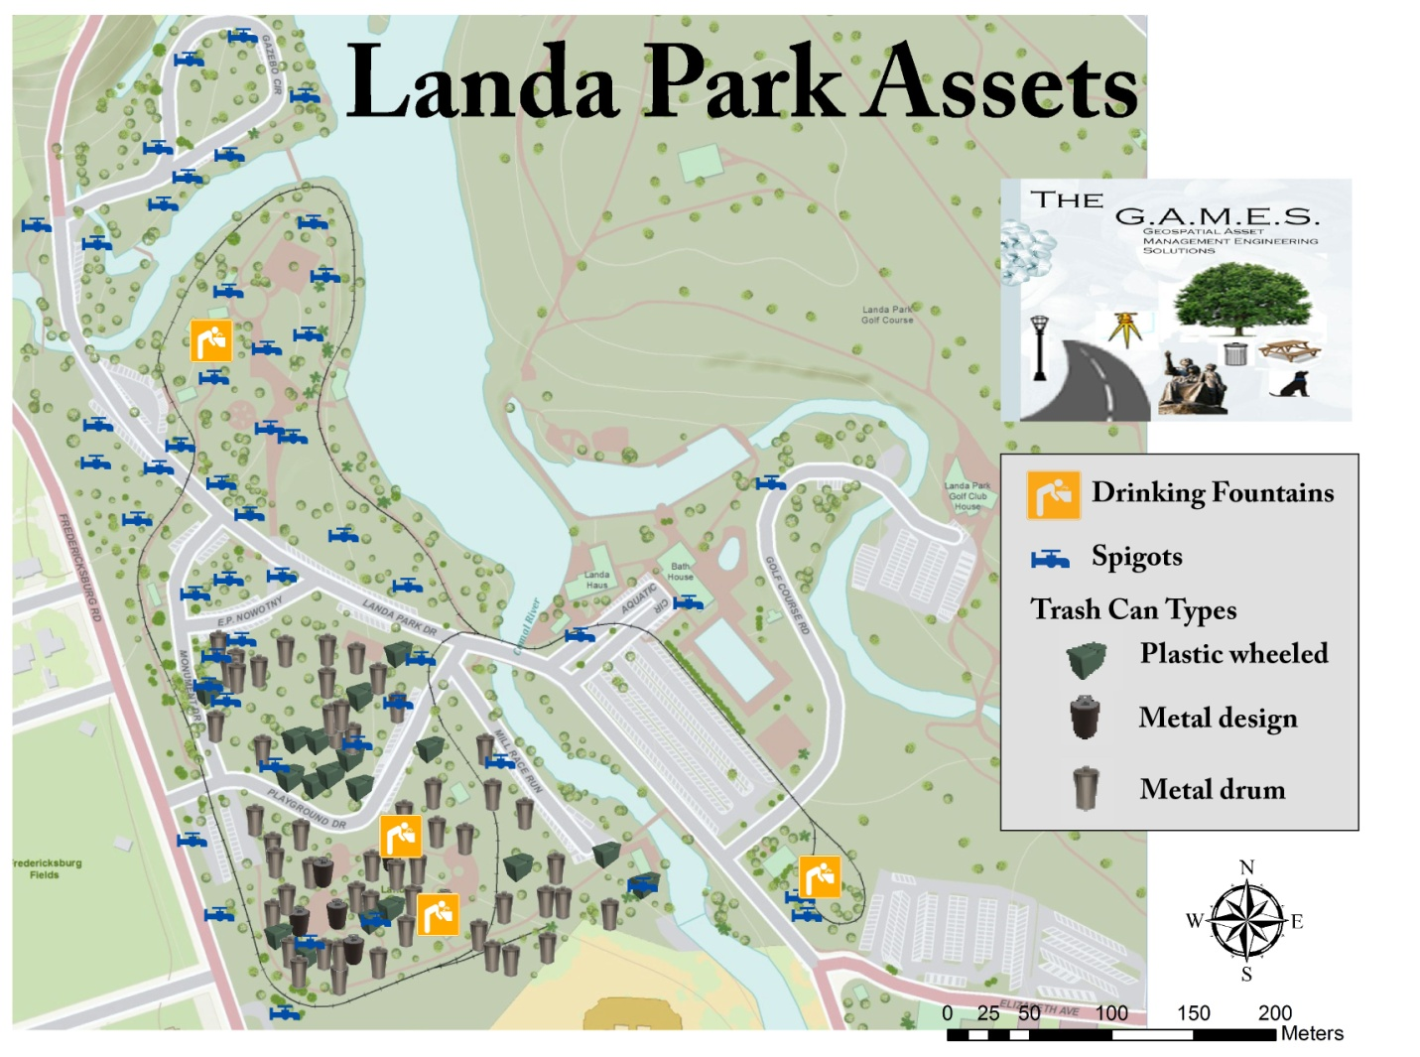

- APPENDIX III. Attribute Tables
Table 3.1
Park Boundaries Attribute Table Example OBJECTID * Shape * AssetID Park Name Address Park Type Council Districts Acreage COMMENTS Year Acquired Shape_Length Shape_Area
8 Polygon 1 Ernest Eikel Field Park 250 S Grape Street Neighborhood 1 4 <Null> 1969 1712.602289 174397.266
30 Polygon 10 Cypress Bend 503 Peace Avenue Community 5 18.1 <Null> 1927 4323.803926 788424.3398
19 Polygon 11 Fischer Park 1820 Old McQueeny Rd Regional 6 62.53 <Null> 2007 7967.584455 2723847.181
23 Polygon 12 Hinmann Island 350 Elizabeth Avenue Community 3,5 5.9 <Null> 1958 5196.295427 257017.3562
33 Polygon 13 West Loop Park 1184 Landa Street Community 3 13.2 Need to check the extent of park and make sure it is correct 2010 3202.58549 574961.1877
20 Polygon 14 Prince Solms Parks 100 Liebscher Drive Community 5 15.53 <Null> 1970 7643.000054 676266.7036
27 Polygon 15 Landa Park 164 Landa Park Drive Regional 3 56.92 <Null> 1936 18938.43195 2479368.512
11 Polygon 16 HEB Soccer Fields 515 Live Oak Special Use Areas 1 14.4 <Null> 1973 4016.306303 627410.7607
16 Polygon 17 Fredricksburg Field 689 Fredricksburg Special Use Areas 3 5.47 <Null> 1954 1966.878997 238256.1654
22 Polygon 18 Landa Golf Course 180 Golf Course Drive Special Use Areas 3,4,5 114.58 <Null> 1936 19351.97281 4991291.225
4 Polygon 19 Lindheimer Plaza 603 Comal Avenue Special Use Areas 5 0.25 <Null> 1845 454.976417 10710.64151
3 Polygon 2 Neighborhood Park 1032 W Coll Neighborhood 6 0.43 <Null> 1969 554.81487 18881.51128
6 Polygon 20 Market Plaza 292 Tolle Special Use Areas 5 0.77 <Null> 1845 1132.427455 33732.29239
7 Polygon 21 Main Plaza 500 Main Plaza Special Use Areas 5 0.47 <Null> 1845 639.931259 20557.42138
31 Polygon 22 Faust Street Bridge Faust Street to Porter Street Special Use Areas 5 1.28 <Null> 1887 2117.606235 55787.46604
12 Polygon 23 Camp Comal 1901 Kuehler Avenue Special Use Areas 6 42.78 <Null> 1975 6207.969426 1863680.835
21 Polygon 24 Union Street Tubers Exit 100 E Lincoln Special Use Areas 5 1.37 Need year Acquired? 0 561.014504 13145.60537
24 Polygon 25 Garden Street Tubers Exit 275 E Garden Street Special Use Areas 5 0.04 Need year Acquired? 0 237.506311 1661.991776
2 Polygon 26 Panther Canyon Landa Park Drive Greenbelt 3 44.85 <Null> 1939 9075.840289 1953467.744
26 Polygon 27 Alves Lane 233 Alves Greenbelt 5 3.27 <Null> 2009 1800.187653 142359.3745
29 Polygon 28 Sunbelt Park Wald Road Greenbelt 1 5.28 Check the extent of park... not sure if the parcel is actual size of park. 1996 2152.588638 229926.3257
1 Polygon 29 River Acres Park 501 Fair Lane Greenbelt 4 1.19 <Null> 1974 1108.48681 51929.73409
5 Polygon 3 Haymarket Plaza 705 Comal Avenue Neighborhood 5 3.47 <Null> 1949 1593.087988 151192.3543
13 Polygon 30 Crest Lane Greenbelt Crest Lane Greenbelt 4 4.44 <Null> 2002-2012 3075.58977 193448.0191
35 Polygon 31 Dry Comal Trails 3565 Loop 337 Greenbelt 1 20.21 <Null> 1995 8903.782062 880138.1845
18 Polygon 32 New Braunfels Cemetery Business 35 and Grape Ave Cemetery 1 4.86 <Null> 1845 1845.632835 211515.0789
34 Polygon 33 Comal Cemetery 301 Peace Avenue Cemetery 4,5 25.11 <Null> 1868 7676.840395 1446927.609
32 Polygon 34 County Line Memorial Trail FM 1044 to FM 725 Greenbelt 6 69.5 <Null> 2011 23304.9171 2348580.616
15 Polygon 35 Tube Chute 452 E Mill Street Special Use Areas 5 1.91 What year was it acquired? 0 1286.289148 83048.94305
9 Polygon 4 Jesse Garcia Park 2580 Katy Street Neighborhood 1 0.89 <Null> 1984 928.730877 38815.3393
17 Polygon 5 Hoffman Park 784 North Park Ridge Dr. Neighborhood 6 0.85 <Null> 1997 831.956994 37067.41152
28 Polygon 6 Solms Park 445 Rusch Lane Neighborhood 1 8.04 <Null> 2003 2431.712197 350185.555
TABLE 3.2
Landscape Maintenance Attribute Table Example
OBJECTID * Shape * AssetID Property Type Property Description Address Property Classification Basic Mowing Shredding Turf Fertilization Granular Trim Ground Cover Prune Shrub Hedges Maintain Flower Beds Pre-Emerge and Fertilize Refresh Remulch COMMENTS Acreage Park AssetID Shape_Length Shape_Area
81 Polygon 1 City Facility City Hall 424 S Castell Ave A 36 0 0 36 12 12 1 2 <Null> 4.14 1747.930951 180489.6009
66 Polygon 2 City Facility Civic Center 375 S Castell Ave A 36 0 1 36 12 12 1 2 <Null> 2.57 1350.735816 111737.2291
68 Polygon 3 City Facility Fire Station # 1 169 S Hill Ave C 24 0 0 4 4 12 1 2 <Null> 1.02 882.810239 44325.70385
69 Polygon 4 City Facility Fire Station # 2 4120 Loop 337 C 24 0 0 4 4 12 1 2 <Null> 1.06 934.593548 46020.85224
67 Polygon 9 City Facility IT Rental House 451 S Castell Ave B 36 0 0 0 0 0 0 0 <Null> 0.31 530.293396 13666.3102
76 Polygon 10 City Facility Police Department 1488 S Seguin Avenue B 36 0 1 36 12 12 1 0 <Null> 4.05 <Null> 1971.608511 176380.5028
82 Polygon 11 City Facility Police Station Rear Parking Lot 1488 S Seguin Avenue B 0 0 0 0 0 0 1 0 Rear Parking Lot 2.16 <Null> 1422.47392 94036.15382
14 Polygon 16 Parks Cypress Bend Park 503 Peace Avenue B 36 0 0 0 0 0 0 0 <Null> 18.1 10 4323.803926 788424.3398
7 Polygon 17 Parks Ernest Eikel Field 250 South Grape C 36 0 0 0 0 0 0 0 <Null> 4 1 1712.602344 174397.2853
16 Polygon 18 Parks Faust Street Bridge Faust/Porter Street B 12 0 0 0 0 0 0 0 <Null> 1.28 22 2117.606235 55787.46604
6 Polygon 19 Parks Haymarket Plaza 705 Comal Avenue C 36 0 0 0 0 0 0 0 <Null> 3.47 3 1593.087988 151192.3543
11 Polygon 20 Parks Hoffman Park 784 Northpark Ridge Drive C 36 0 0 0 0 0 0 2 <Null> 0.85 5 831.956994 37067.41152
2 Polygon 24 Parks Main Plaza 500 Main Plaza A 52 0 1 6 4 52 1 2 <Null> 0.47 21 639.931199 20557.41898
1 Polygon 25 Parks Main Plaza Islands 500 Main Plaza A 0 0 0 6 4 52 1 2 Same Park Asset ID as Main Plaza? 0.06 449.726136 2776.14291
3 Polygon 26 Parks Market Plaza 292 Tolle C 24 0 0 4 4 12 0 0 <Null> 0.77 20 1132.427325 33732.2945
13 Polygon 30 Parks Sunbelt Park Wald Road D 12 0 0 0 0 0 0 0 <Null> 5.28 28 2152.588638 229926.3257
78 Polygon 33 Roads and Medians County Line Road Medians FM 725 to FM 1044 C 18 0 0 0 0 0 0 0 <Null> 0.02 <Null> 12624.34077 61864.23126
83 Polygon 34 Roads and Medians Tubers Shuttle Zone 100 E Lincoln B 24 0 0 0 4 0 0 0 <Null> 1.37 24 1624.50246 46644.6057
77 Polygon 35 Roads and Medians Walnut Extension Medians County Line Road to Klein Road B 36 0 0 6 4 36 0 2 <Null> 0.07 <Null> 8405.393077 39780.53308
80 Polygon 36 Undeveloped/Flood Properties West Loop Park 1184 Landa Street C 0 6 0 0 0 0 0 0 Need to check the extent of park and make sure it is correct 13.2 13 3202.58549 574961.1877
52 Polygon 37 Undeveloped/Flood Property 1103 Rivercrest Dr 1103 Rivercrest Dr C 18 0 0 0 0 0 0 0 <Null> 0.67 725.386477 29125.88692
50 Polygon 38 Undeveloped/Flood Property 1115 Rivercrest Dr 1115 Rivercrest Dr C 18 0 0 0 0 0 0 0 <Null> 0.34 488.47353 14758.76884
47 Polygon 76 Undeveloped/Flood Property 641 Crest Ln 641 Crest Ln C 18 0 0 0 0 0 0 0 <Null> 0.55 680.53968 23791.57764
29 Polygon 77 Undeveloped/Flood Property 812 Candlewood Cir 812 Candlewood Cir C 18 0 0 0 0 0 0 0 <Null> 0.25 433.830749 10871.79987
28 Polygon 78 Undeveloped/Flood Property 815 Candlewood Cir 815 Candlewood Cir C 18 0 0 0 0 0 0 0 <Null> 0.25 422.662549 10888.20282
27 Polygon 79 Undeveloped/Flood Property 819 Candlewood Cir 819 Candlewood Cir C 18 0 0 0 0 0 0 0 <Null> 0.29 452.208099 12671.16532
49 Polygon 80 Undeveloped/Flood Property Alves Lane Park 233 Alves Ln C 0 6 0 0 0 0 0 0 <Null> 3.27 27 1800.187653 142359.3745
41 Polygon 81 Undeveloped/Flood Property Fischer Property 1820 McQueeny Road C 24 0 0 0 0 0 0 0 <Null> 3 11 7967.584455 2723847.181
48 Polygon 82 Undeveloped/Flood Property Landa Plaza 345 Landa Street C 24 0 0 0 0 0 0 0 <Null> 7.28 2450.64105 356001.5409
63 Polygon 83 Undeveloped/Flood Property Morningside Park 3737 Morningside Dr D 0 6 0 0 0 0 0 0 <Null> 17.02 8 3667.478746 741354.6103
18 Polygon 53 Undeveloped/Flood Property 307 Fair Lane 307 Fair Lane C 18 0 0 0 0 0 0 0 <Null> 0.72 760.400541 31495.64695
19 Polygon 54 Undeveloped/Flood Property 311 Fair Lane 311 Fair Lane C 18 0 0 0 0 0 0 0 <Null> 0.52 642.363681 22816.66287

Appendix IV. Personal Reports/Contributions
Nathan Andrews:
For the proposal I wrote the Introduction, Purpose, Scope, Cover Page, and I designed the Logo and Budget. I also made the power point presentation and did a lot of the organizing and editing. For the first stage of our project working on the park boundaries and landscape maintenance layers we received the preliminary data for these properties on paper spreadsheets. We then divided the spreadsheets information up equally among us. Mr. Flynn mentioned using parcel data to represent the spatial locations of the parks/landscape maintenance properties and getting it to us sometime later in the week. However, I found the parcel and address data we needed on their websites data extraction page and verified that it was correct with Mr. Flynn. I then told the rest of my group where to find the data and how to extract the correct information. Then I proceeded to find the parcels for the properties I was assigned and digitized in over 20 road medians, the main plaza islands and others. On the day I was supposed to gather everyone’s data together and compile it into a finished product for the next day’s meeting with Mr. Flynn I found out that a group member didn’t do their portion. So I gathered up everyone else’s data and started working on the portion that wasn’t done. When I finished with that there was another group member’s data that was not compatible to the rest of the data and had incorrect features digitized. So I had to redo most of that group members work as well. After all the data was finished and corrected I populated all the attribute tables based off of the spreadsheets data. Then I brought it to the meeting along with the shapefiles and geodatabase for Mr. Flynn.
The progress report was worked on next and I was assigned to the Introduction, Project Description, Purpose, and Scope again. I created some attribute tables for the report as well. For the next part of the project we collected data for assets located within the Parks and Recreation Departments properties. These assets were picnic areas, pavilions, drinking fountains, spigots and trash cans. For this stage I printed out 20 plus aerial photos at scales of 1:1000 and 1:400 covering most of Landa Park and placed them in a 3-ring binder. This task was assigned to someone else but I assumed he would forget or wouldn’t and so I went ahead and did it, good thing too. No one had anything and I had to go back to my house after class and print out another 2 binders worth of photos for my group members. The second time I have run out of ink printing this semester. Once we were in Landa Park with the binders full of photos we started collecting data. This data consisted of locating all of the spigots or drinking fountains in the park then marking the relative location as best we could on the paper aerial photos. We were also collecting the presence and count of trash cans and bbq pits (pit size as well) near picnic areas/pavilions. I helped collect this data until the group had to leave. Then I stayed behind and collected all the rest of the spigot and drinking fountain data myself and finished the count/presence of trash cans and bbq pits for the remaining picnic areas and pavilions. I took this data and digitized all of the spigots and drinking fountains into their respective layers and created attribute tables and domains. Then I got Kevin’s finished GPS data on the pavilions and picnic areas and combined them into a single geodatabase with my data. This geodatabase was given to Mr. Flynn at the next meeting and he then asked if it would be possible to collect data on trash cans. As a group we said “sure it was possible” and so that same day after we got back to San Marcos I went back to New Braunfels and collected data on 85 trash cans using the paper aerial photos and locating the trash cans then marking their spatial location on the map. I also inventoried the type of trash can, mount type and lid type as well as took pictures of each different trash can so that Mr. Flynn could use them if needed to show as a thumbnail of the asset in Accela. Those pictures went with the other 100 plus pictures I took of Landa Park and other parks assets when I did my research on the type of assets the parks may want to keep track of. I took the trash can data I collected and digitized it. Then I created the attribute tables and domains for the trash can type, mount, and lid type. This layer was finished and emailed to Mr. Flynn the same day he asked for it. Included in the data I emailed to Mr. Flynn was an addition of the police shooting range parcel data (we couldn’t find it, then I did) to the landscape maintenance layer, a boundary issue on the Landa Park and Landa Golf Course I fixed, and an extra drinking fountain that I found in Landa Park when collecting trash can data.
In the final report I was assigned to the Introduction/Problem Statement, Purpose, Scope, Methodology, Flow Charts, Appendix II. Figure 2.2, and I did some of the editing/organization. I also found the poster design we used and populated over half of it with data. The remainder of the data was done by Kevin and me later. The website design and everything about it was done by me as well. I created one that I couldn’t get to work correctly on the schools computers. So I created a second site using a different format and template and got it to work on the schools computer. I plan on adding the last links to the final papers Monday or Tuesday of Final’s week.
I think that’s enough contribution’s to mention for now, aside from all the notes, research, printouts, and general staying on top of things for meetings. In all I had a wonderful experience working on a great project and learning from Dr. Lu in the classroom and Mr. Flynn in the field. This project has opened my mind up to the unlimited possibilities in my future and I am looking forward to employing the knowledge and skills I have learned wherever I go.

